## Table of Contents

1. Overview 2
2. Scope 2
3. Roles/Responsibilities 3
4. Entry And Exit Criteria 3
   1. Entry Criteria 3
   2. Exit Criteria 4
5. Suspension Criteria And Resumption Requirements 4
6. Test Strategy 4
   1. QA role in test process 4
   2. Bug life cycle: 5
   3. Testing types 5
   4. Bug Severity and Priority Definition 5
7. Testing Tools 6
8. Test Schedule 6
9. Test Deliverables……………………………………………………………………….7

10 Approvals 7

**Test Plan**

## Project “BStackDemo”

## Overview



Customer wants a perfect website, which passed the full cycle of manual testing. Given the specificity of the site it is very important to have the same quality and the site.

This document describe approaches and methodologies that will apply to the unit, integration and system testing of the “https://bstackdemo.com/". It includes the objectives, test responsibilities, entry and exit criteria, scope, schedule major milestones, entry and exit criteria and approach. This document has clearly identified what the test deliverables will be, and what is deemed in and out of scope.

## Scope

The document mainly targets the GUI testing and validating data in report output as per Requirements Specifications provided by Client.

* 1. Functions to be tested.
     + GUI
     + Search and Filters Logic
     + Performance
  2. Functions not to be tested.

1. Not other than mentioned above in section

## Roles and Responsibilities

|  |  |  |
| --- | --- | --- |
| **Name** | **Role** | **Responsibilities** |
| Person A | Test Manager | 1. Escalations |
| Person B | Test Lead | 1. Create the Test Plan and get the client signoffs 2. Interact with the application, create and execute the test cases 3. Report defects 4. Coordinate the test execution. Verify validity of the defects being reported. 5. Submit daily issue updates and summary defect reports to the client. 6. Attend any meeting with client. |
| Person C | Senior Test Engineer | 1. Interact with the application 2. Create and Execute the Test cases. 3. Report defects |
| Person D | Test Engineer | 1. Interact with the application 2. Execute the Test cases. 3. Report defects |

## Entry And Exit Criteria

## Entry Criteria

* All test hardware platforms must have been successfully installed, configured, and functioning properly.
* All the necessary documentation, design, and requirements information should be available that will allow testers to operate the system and judge the correct behavior.
* All the standard software tools including the testing tools must have been successfully installed and functioning properly.
* Proper test data is available.
* The test environment such as, lab, hardware, software, and system administration support should be ready.
* QA resources have completely understood the requirements
* QA resources have sound knowledge of functionality
* Reviewed test scenarios, test cases and RTM

## Exit Criteria

* A certain level of requirements coverage has been achieved.
* No high priority or severe bugs are left outstanding.
* All high-risk areas have been fully tested, with only minor residual risks left outstanding.
* Cost – when the budget has been spent.
* The schedule has been achieved

## **5 Suspension Criteria And Resumption Requirements**

Based on the Client decision, we will suspend and resume the Project. We will ramp up and ramp down the resources as per Client needs.

# 6 Test Strategy

## 6.1 QA role in test process

* Understanding Requirements
* Preparing Test Cases
* Preparing Test Matrix
* Reviewing test cases and matrix



* Creating Test Data
* Executing Test Cases
* Retesting and Regression Testing
* Deployment/Delivery

## 

## 6.2 Bug life cycle:

All the issues found while testing will be logged into Word document.



Bug life cycle for this project is as follows:

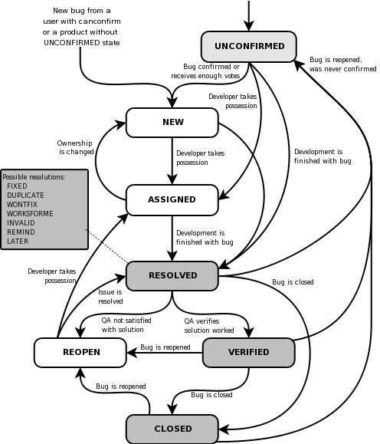

## 6.3 Testing types

- Black box Testing

- GUI Testing

- Integration Testing

- Functional Testing

- System Testing

- Performance Testing

* User acceptance Testing

- Alpha Testing

## 6.4 Bug Severity and Priority Definition

Bug Severity and Priority fields are both very important for categorizing bugs and prioritizing if and when the bugs will be fixed. The bug Severity and Priority levels will be defined as outlined in the following tables below. Testing will assign a severity level to all bugs. The Test Lead will be responsible to see that a correct severity level is assigned to each bug.

## 7 Testing Tools

|  |  |
| --- | --- |
| Process | Tool |
| Test case creation | Microsoft Excel |
| Test case tracking | Microsoft Excel |
| Test case execution | Manual, Selenium |
| Test case management | Microsoft Excel |
| Defect management | Microsoft Word |
| Test reporting | PDF |
| Check list creating | Microsoft Excel |

## 7.1 Test Environments

1. Windows 10 – Chrome, Firefox and Edge
2. Mac OS – Safari Browser
3. Android Mobile OS – Chrome
4. iPhone Mobile OS - Safari

## 8 Test Schedule

Following is the test schedule planned for the project –

|  |  |
| --- | --- |
| Task | Time Duration |
| Creating Test Plan | Start Date to End Date |
| Test Case Creation | Start Date to End Date |
| Test Case Execution | Start Date to End Date |
| Summary Reports Submission | Date |

## 9 Test Deliverables

The following are to be delivered to the client:

|  |  |  |
| --- | --- | --- |
| Deliverables | Description | Target Completion Date |
| Test Plan | Details on the scope of the Project, test strategy, test schedule, resource requirements, test deliverables and  schedule | Date |
| Functional  Test Cases | Test Cases created for the scope defined | Date |
| Defect Reports | Detailed description of the defects identified along with screenshots and steps to reproduce on a daily basis. | NA |
| Summary Reports | Summary Reports – Bugs by Bug#,  Bugs by Functional Area and Bugs by Priority | Date |

# **10 Approvals**

Team will send different types of documents for Client Approval like below:

1 Test Plan

2 Test Scenarios

3 Test Cases

4 Reports

Testing will only continue to the next steps once these approvals are done.